Project Name: OnlineMedico

Version 1.5
June 30, 2020

Team Members:
Akhitha Tumula
Satish Kumar Mandapalli
Rohan Bhandari
Sravani Jaidi
Kavya Reddy Mylapurapu
Rethima Reddy Polam

Submitted in partial fulfillment
Of the requirements of
CSIS 44-691 Graduate Directed Project 1

Revision History

Date | Description | Author | Comments
<date> | <Version 1> | <Your Name> | <First Revision>
June 10,  2020 | 1.1 | Akhitha,Satish,Rohan,Sravani,Kavya,Rethima | Added functional requirements
June 11,2020 | 1.2 | Akhitha,Satish,Rohan,Sravani,Kavya,Rethima | Added Mock-ups
June 16, 2020 | 1.3 | Akhitha,Satish,Rohan,Sravani,Kavya,Rethima | Added additional functionalities
June 29,2020 | 1.4 | Akhitha,Satish,Rohan,Sravani,Kavya,Rethima | Connected Front-end and Backend
June 30,2020 | 1.5 | Akhitha,Satish,Rohan,Sravani,Kavya,Rethima | End user manual

Document Approval

The following Software Requirements Specification has been accepted and approved by the following:
Signature | Printed Name | Title | Date

Table of Contents

Table of Contents Page Number

- Introduction ……………………………………………………6
  - Purpose ………………………………………………….....6
  - Scope ………………………………………………….......6
  - Definitions, Acronyms, and Abbreviations ……………….6
  - References ………………………………………………...6
  - Overview ………………………………………………….7
- General Description
2.1 Product Perspective …………..............................................8
2.2 Product Functions ………..................................................8
2.3 User Characteristics …………………………………….…8
2.4 General Constraints ………………………………………..8
2.5 Assumptions and Dependencies …………………………...8
- Specific Requirements
3.1. External Interface Requirements …………………............10
3.1.1. User Interfaces ……………………………………10
3.1.2. Hardware Interfaces ……………………………....10
3.1.3. Software Interfaces ……………………………….10
3.1.4. Communications Interface ……………………..…10
3.2. Functional Requirements ………………………………….10
3.3. Use Cases …………………………………………………13
3.4. Class/Objects
3.5. Non-Functional Requirements ……………………………13
3.5.1. Performance ……………………………………..13
3.5.2. Reliability …………………………………….….13
3.5.3. Availability ………………………………………13
3.5.4. Security …………………………………………..13
3.5.5. Portability ………………………………………..13

3.6. Inverse Requirements
3.7. Design Constraints
3.8. Logical Database Requirements
3.9. Other Requirements
3.10. Prototypes (for complete project)
3.11. Use Case Diagrams
- Design ……………………………………………………14
4.1. ER diagram …………………………………………14
4.2. GUI …………………………………………………15
- Technical Manual ………………………………………..27
- End User Manual ……………………………………….. 40

Chapter 1: Introduction
1.1 Purpose:
To buy medicines in any business area, we usually go there in person. In our everyday life, we often come across such issues. So, our main aim of this project is to buy medicines online based on the location and available drug stores of those business areas especially for the senior citizens. Website has both perspectives like the user can place orders for required medicine and also they can upload the prescription and the admin can accept or reject the requested medicines based on their availability and validity of prescription. To begin with we are working on a website that can buy medicines online in the drug stores nearby along with this they can also upload prescription and further this can be extended more to book appointments at any business area like hospitals for doctor consultation.
1.2 Scope:
New users have to register themselves with their details to use the Website. After registering, the user needs to give permission to location access. If the user is already registered, they need to login using their credentials. Based on the location, for all users i.e. existing and new users the website displays nearby drug stores where medicines can be ordered online by selecting a particular drug store.

The website displays the drug stores which were nearby to your location. Users can go through their profile in settings where they can edit their credentials including their mobile number. If an individual wants to change password, they get a confirmation message to their registered mail or mobile number and then after confirmation the password is updated.

Admin will add all the drug stores at particular locations and also they can add or delete the medicine from the store. Once it is registered, the drug store is visible to the nearest users to place orders for medicines available. They can edit medico profile and drug store details and their availability of medicines and delivery facility So that the user can select the available medicines by placing a request which were not available when they were searching (gets after updating).
Users can pay through online after the medicines are added to cart. One has the option to save their card details during payment for future use. The application can be used within ten miles of radius around the globe for users. It displays drug stores to the user based on the radius. It can be used within a city with many numbers of users.
1.4 References:

1.5 Overview:
Instead of going to drug stores to buy medicines, you can directly buy them with registered drug stores online by uploading prescription using this website. Can find drug stores within 10 miles radius. Payments can be done online. Admin can accept the request made by the users for particular medicines when they are available and notify the users. Can reach a selected drug store using maps for pickup also.

Chapter 2: General Description

2.1 Product Perspective
Our website OnlineMedico, will help people find their medication and buy them easily. This website makes the user find the available store to buy their medications. In our application, there are two main users. They are
- Admin
They can see all the orders that are sent to stores present in a specific location.
- General Users
They can view the list of nearby pharmacies and can view the list of drugs that are available in their store to purchase. If the purchase of any medicine needs a prescription then they can upload it and add them to cart. Once they found all the needed drugs they can order through home delivery or through self-carry out.
2.2 Product Functions
The website functions in two different ways based on the person logged in. If a drug provider is logged in, their functionalities will be enabled like adding medical drugs into their store, to view the list of online orders, view order history, view complaints (if any) and to view the requests for new drugs. And if the person logged in is a general user, their functionalities like finding nearby pharmacies and searching for required drugs. Then to add them to cart and order online.
2.3 User Characteristics
Here are a few user characteristics for our project.
- Every admin has login credentials, contact details, address, list of drugs available
- Every Customer has login credentials, name, contact details, address and access to payment gateway.
2.4 General Constraints
There are constraints a user must contain to use our application. They are
- User must be in a position to access computer or any other device to browse the website
- User must be able to connected to internet
- Users must be educated enough to search for the medicine they need.
2.5 Assumptions and Dependencies
While creating our project we made some assumptions. They are as follows:
- The admins are willing to share their drug details in our application
- The admins are willing to accept online orders and payments.
- The users are well educated and are able to understand the description of each medicine provided in our application.
- The users are willing to pay online for the drugs.
Below are the dependencies we have in our project.
- Our project is mainly dependent on pharmacy owners and their trust in our application.

Chapter 3: Specific Requirements
3.1. External Interface Requirements
External interface requirements specify hardware, software, or database elements with which a system or component must interface...." This section provides information to ensure that the system will communicate properly with external components.
3.1.2. Hardware Interfaces
- Processor: Minimum 1 GHz; Recommended 2GHz or more
- Ethernet connection (LAN) OR a wireless adapter (Wi-Fi)
- Hard Drive: Minimum 32 GB; Recommended 64 GB or more
- Memory (RAM): Minimum 1 GB; Recommended 4 GB or above
3.1.3. Software Interfaces
- Vscode
- Node js
- React js
- Windows: 7 or newer
- Mac: OS X v10.7 or higher
- Linux: Ubuntu
3.2 Functional Requirements
OnlineMedico is a website where the users can buy medicines online from the registered drug stores. Here, Drug stores are the clients and websites are the link to buy the medicines for users. Presently there is no existing platform to buy the medicines online and to make a request for required medicines to buy later. So, the main purpose of the website is to make the client’s business easy.
Responsive design for varying screen size, Version compatibility for devices, more touch flexibility and less keyboard usage in the application are the features of the website. The other main feature of the website is data security. Payments are also available on the website users can pay after adding medicines to their cart or can pay with cash if it is picked up.
Requirements
Below are requirements for customers
- Login (sign up, sign in, password retrieval, logout):
Store owner and customer has to first register (signup) into the application. After registration is done with required details, using username and password user can login to the application. If a user forgets his/her password, they can change their password using verification code sent to a registered email. A logout button is provided to logout of the application

- View drug list:
When a user logs into the application, he/she can be required to another page where a list of drugs are viewed (for which prescription is not needed) and also an upload prescription button. When the upload prescription button is clicked, a page will be redirected to a page that contains drug stores list and after the user selects a drug store, medicines of that drug store can be added to cart with prescription uploaded.
- Search/filter:
A search or filter option is available where user can sort by either drugs price or stores nearby and also can search for particular store or drug by typing the name
- Cart management (add/modify/delete):
In this activity customers can add their desired medicines into the cart before placing orders. Customers can also modify the orders or quantity of items in an order after adding to cart and can delete the items which are already added to cart.
- Place orders:
After adding items to cart and payment is done, the drug store owner will be getting a notification to approve the order. After it is approved by verifying prescription and payment details, Order will be placed.
- Confirmation:
After request for medicines is approved by verifying prescription and payment details, Order will be placed, and the customer will be getting a notification about confirmation of order.
- Checkout:
This is the page after adding items to cart where customers can pay the amount using different types of payment methods that are available.
- Check active order (track, return, cancel):
Customers after order is confirmed and placed, they can track the status of order like it is shipped, out for delivery and delivered. Before order is shipped customers can cancel their order if they want and money will be refunded within a week. Customers can return the medicine after it is delivered and after it is verified, money will be refunded within a week of return.
- Check history:
Customers can check their previous orders history by clicking your orders button, all the orders that are delivered and ready to deliver will be viewed along with details of the drugs like date of order, quantity and price of drugs.
- Live chat
Through this functionality, we can connect the customers and admins directly. Whenever we have any queries regarding the app, mediation we provide or the delivery of drugs customers can contact the admin at any point of time using our application.
- FAQ (Contact us) (email, textbox)
Frequently Asked Questions (FAQ’s) is functionality in which we include mostly asked questions by the customers. Questions may be regarding the application, drugs we provide, regarding the payments or even regarding the delivery of products.
- Prescription management.
Considering the importance of proper usage of drugs, we have a functionality where the customer is asked to upload the prescription to buy a few drugs. Using this functionality, we will authenticate the correctness of the prescription and only then allow user to buy the drugs
- Profile management
This is a common functionality to all the users. Through this feature any user can view their details like user name, mail Id, contact details, address they have provided during the registration process. They can also update the data whenever required.
Below are the requirements for Admin:
- Login (sign up, sign in, password retrieval, logout)
This login page is similar to the login page of customers, where the user has to provide the credentials like username and password to log in to their dashboard. Links to pages like sign-up / register, password retrieval are also provided.
- Profile
This is the same as the profile page of the customer. The data like user name, mail Id, contact details, address they have provided during the registration process are shown. Along with their details, they can update any of them if required.
- Drug management
This functionality is a kind of statistical page where the admin can view some sort of statistics like the number of drugs sold today, this week and this month. Along with that number of orders placed.

- Notification
Every update regarding the delivery, payment and all things will be updated to the admin using push notifications.
- Listing of orders
In this feature, a list of all the orders delivered will be present with the contact details of both delivered and received persons.

3.3 Use Cases:
3.4 Non-Functional Requirements:
● Devices must have active Internet services.
● This Website should be user-friendly
● This Website should have less response time
● All the sensitive information will be encrypted.
● The user can access only a few drug stores that are registered with this website.
● Users can even pay manually at the drug store if they have opted for a medicine pickup option.
● We should have a database to store all the data such as user information and all their medicine request details.
● This website should find all nearby drug stores registered with the website .
3.4.1. Performance:
● Less battery consumption while using the website.
● Managing memory by keeping track of each memory allocation by Dalvik Virtual Machine.
3.4.2. Reliability:
● 10000 requests can be handled per second.
● Website takes less than 100ms API response time.
3.4.3. Availability:
● It displays the drugstores within 10 miles radius from the current location.
● It also displays the updated availability of medicines in any drug store from time to time.
3.4.4. Security:
● Strong security that balances great encryption and good performance.
● Restricting access to sensitive permissions makes websites less vulnerable for attackers.
3.4.5. Portability:
● Website can be used on mobile devices, tablets, laptops and computers.

Chapter 4: Design
4.1. ER diagram

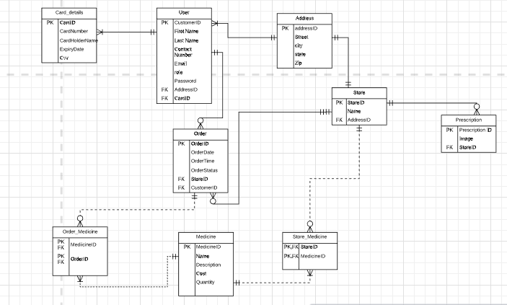
E-R Diagram:
Every customer has at least one card details and each card has exactly one customer. Every customer has exactly one address and at each address there will be at least one customer. Each customer may or may not place an order or multiple orders and each order will have a mandatory customer. Each store has exactly one address and at each address there will be exactly one store. Each store may or may not have prescriptions and each prescription will have exactly one store. Each store may or may not have one or many orders and each order belongs to exactly one store. Each store will have one or many medicines and each medicine may or may not be in one or many stores. This a M:M relationship so we are using an associative entity Store_medicine. Each order has at least one medicine and each medicine may or may not be in one or many orders. This a M:M relationship so we are using an associative entity Order_Medicine.

4.2. GUI

Home page:

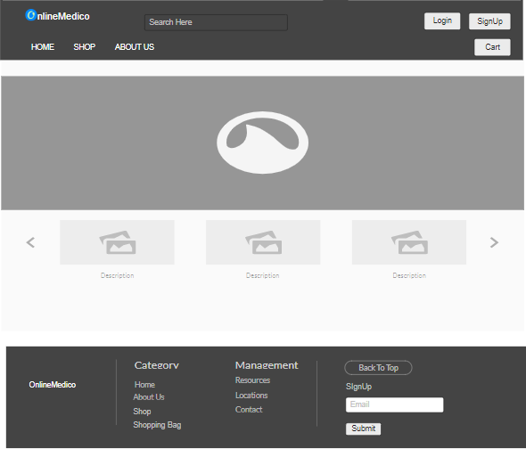

Registration page:

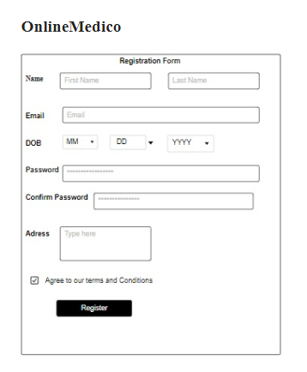

Login page:

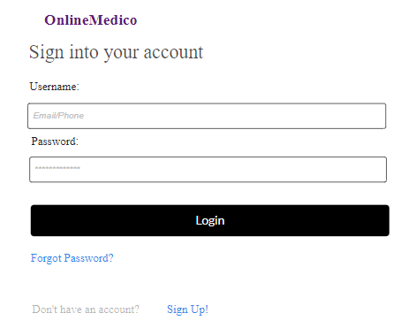

Drug list page:

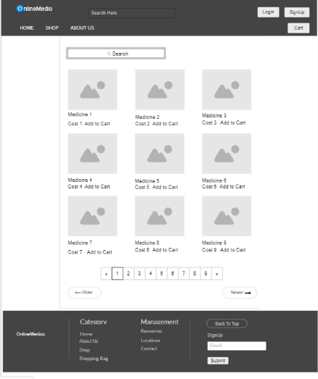

Add To Cart Page:
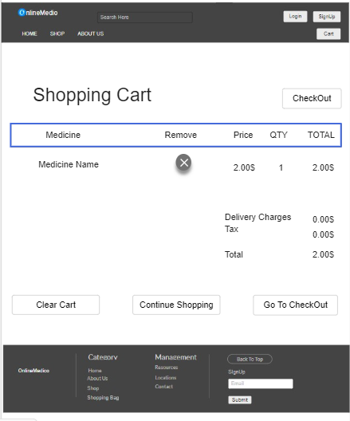

Checkout page:
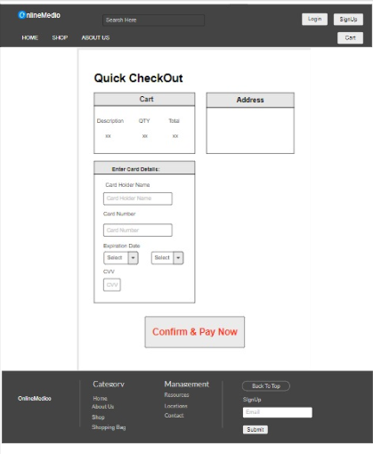

Order confirmation page

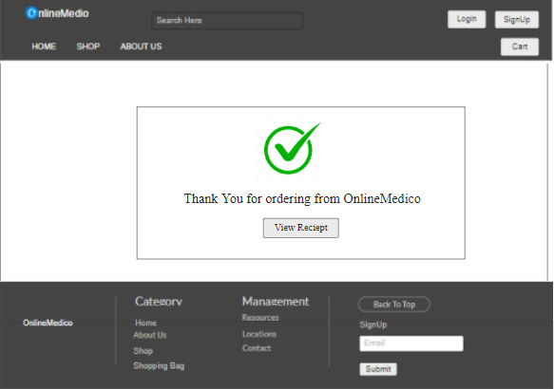

Customer profile page:
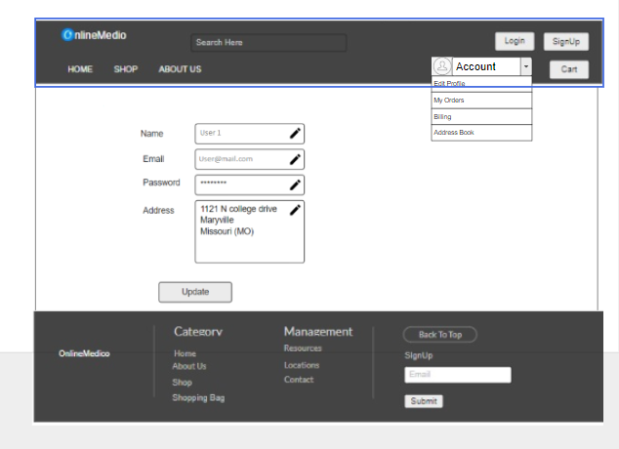

Active Orders

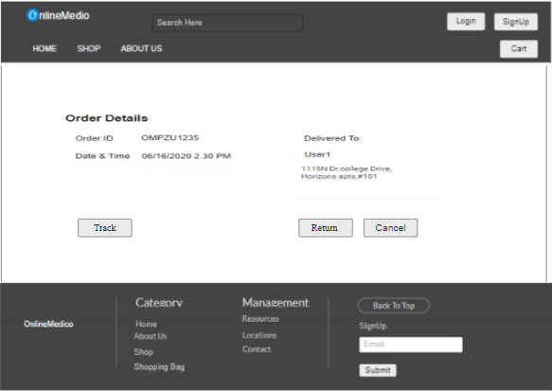

Previous orders page:

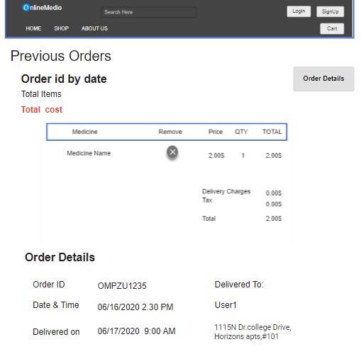

Admin home page:

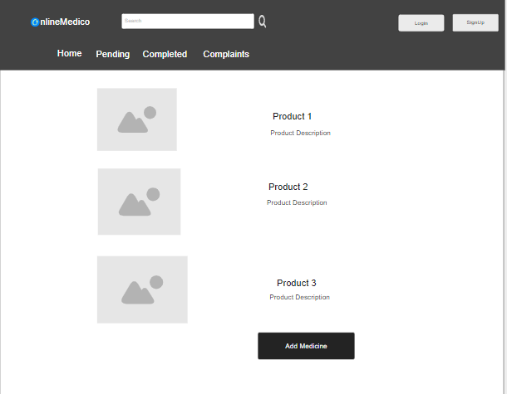

Update information page of Admin:

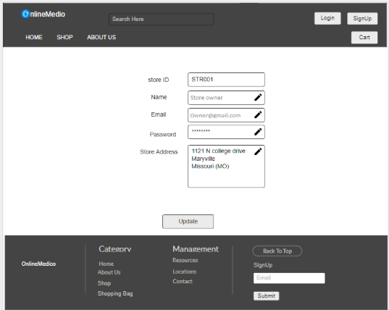

Chapter 5: Technical Manual

Signup Page:

- Created form with JSX code with fields fullname, email, password, confirm password, contact number and with submit button.
- In order to do validation, the constructor by passing props assigned all the fields to null using state property which keeps track of local state of the component.
- validEmailRegex variable holds the regex rules to check whether or not the given input is a valid email.
- validForm function checks whether or not any of the input fields have any errors. If there are any errors, the function outputs it on the console.
- The actual rules of validation are written in handleChange function which has switch case implementation rules specific to the input field.
- The given data is sent to the backend using signup function in JSON format.
- Styling to the page is written using CSS.
Code of signup page:
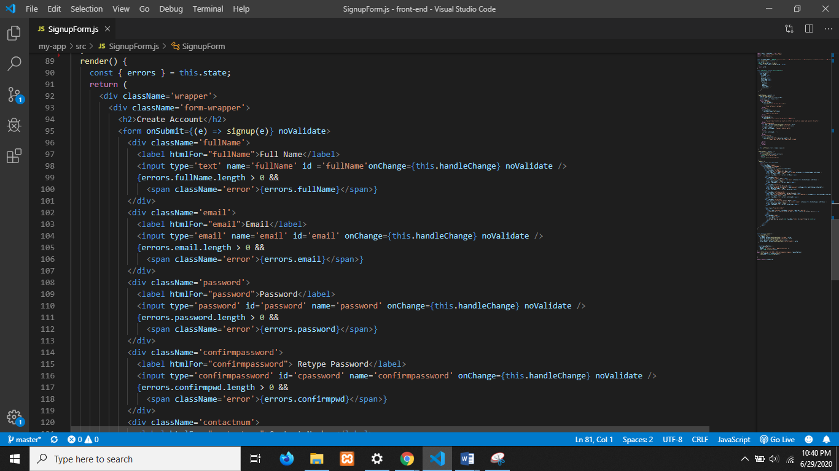
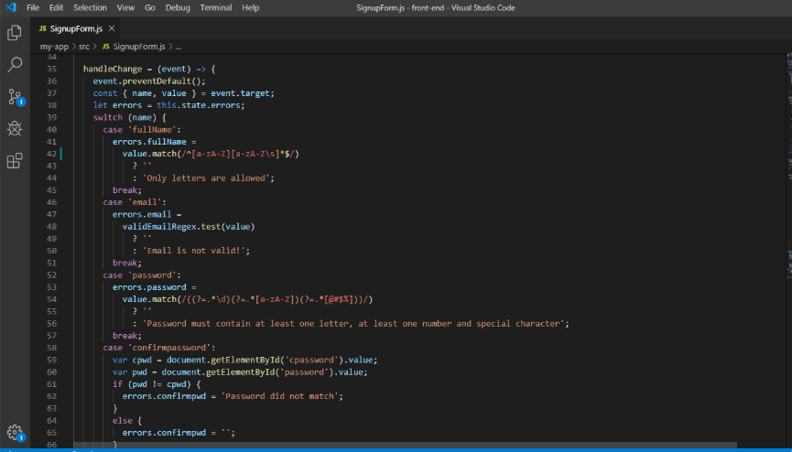

UI of signup page:

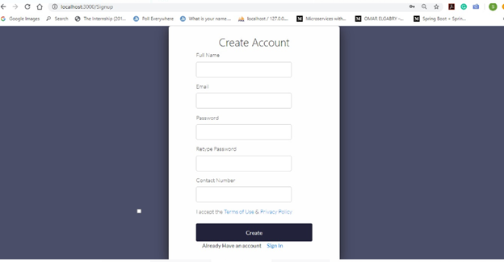

Login Page:
Two input labels email and password where the user enters the data. Add signup and forgot password links that are redirected to those pages. These are differentiated by columns using bootstrap. It also verifies the validation of the email and password and a popup will be displayed if they won’t enter any values in the input. The login function is used to send the entered data to the controller where it is stored in the database and perform certain actions. The controller sends the success message or the error message where it will be displayed in the label.

The stylings of this page are placed under the CSS folder i.e login.css

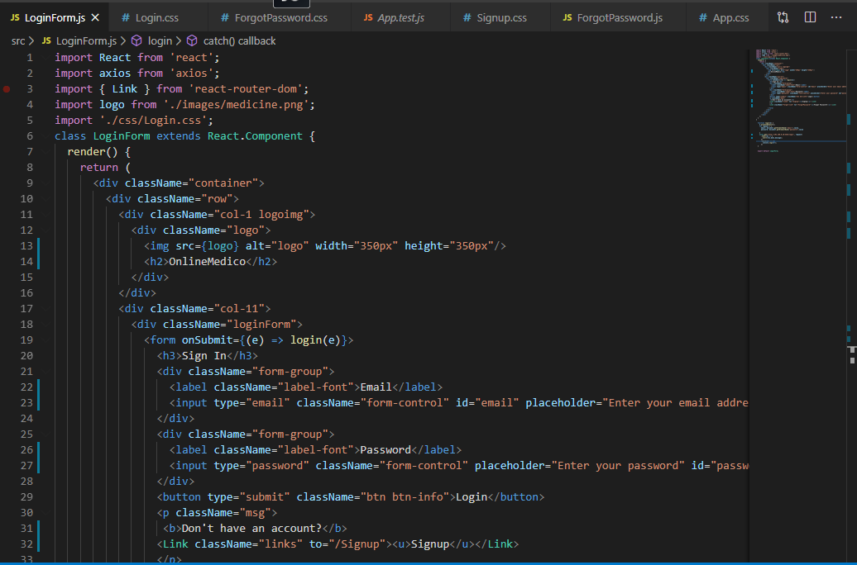
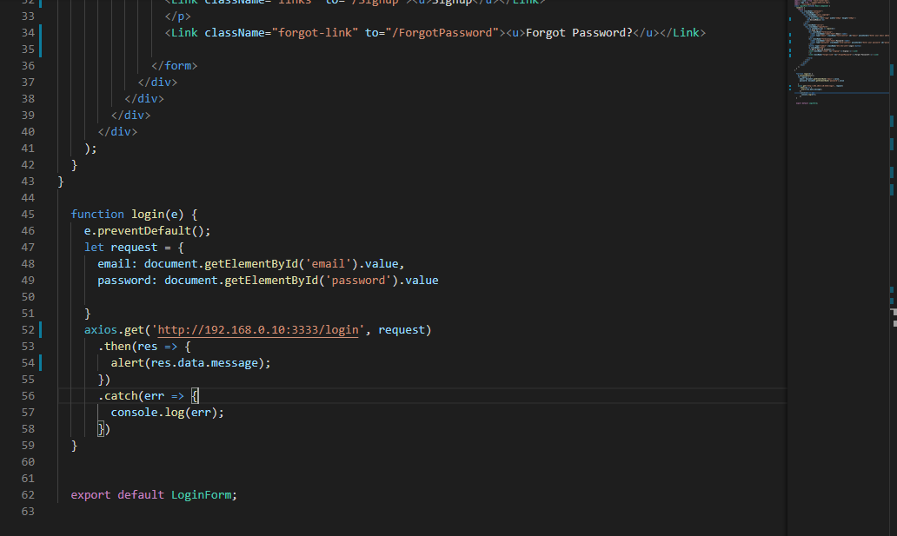
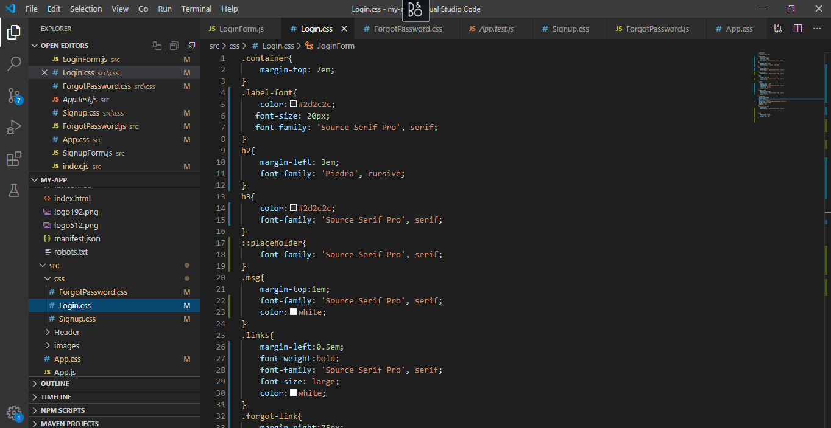

UI of login page:

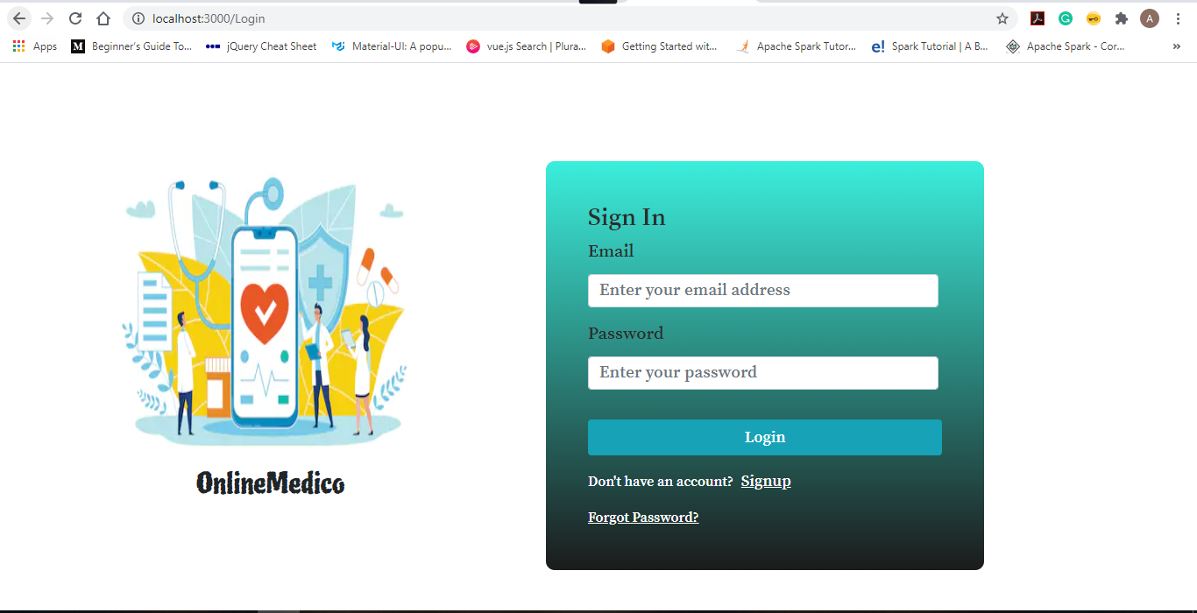

Forgot Password:
There is a forgot password link, when it is clicked then it will be redirected to a page where it has the one input label and button i.e. email and submit button\=.When the send link is clicked, an email to reset password will be sent to reset the password and an error will be caught if the wrong email is entered. The forgot password function will help to connect to the backend where it sends the json object of email to the controller and then it checks the email entered and a successful message will be displayed on the screen for the user.
The styling of this page are placed under the css folder i.e. ForgotPassword.css

Code of forgot password page:
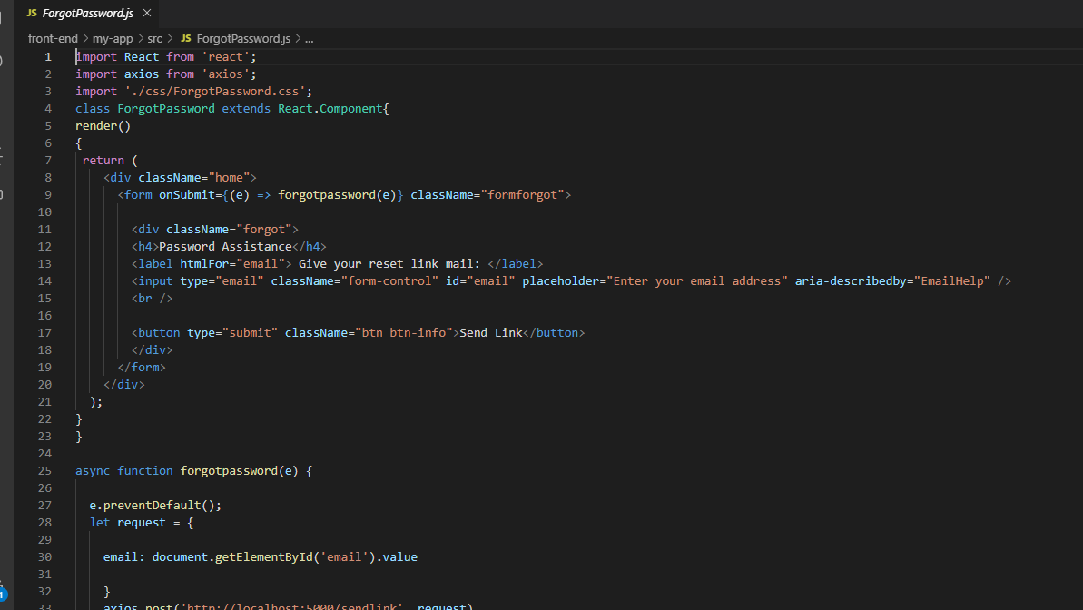

UI of forgot password page:
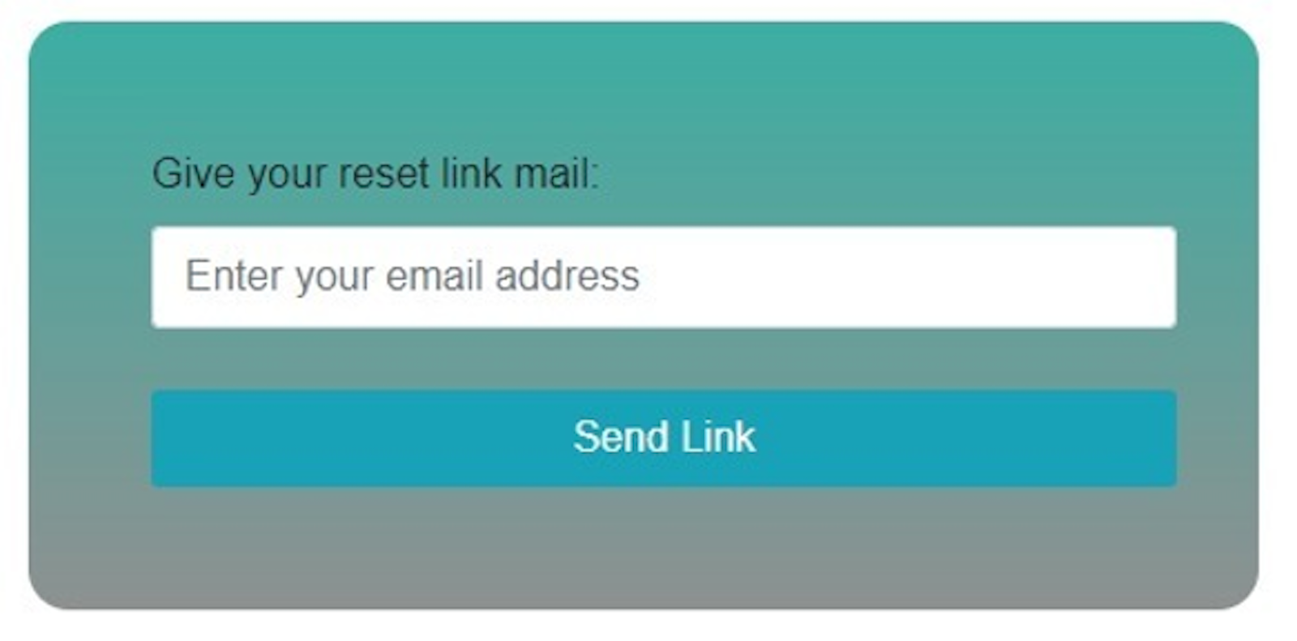

Reset Password:
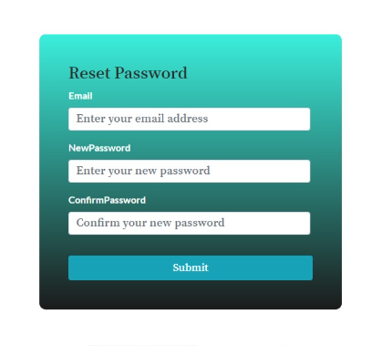
This page has three input labels each for email, new password and for confirming the new password and a submit button. When the submit button is clicked, the password gets updated and this function is handled by the function resetpassword which sends the required data to the controller which performs the necessary actions to update the password and sends the response on successfully updating the password,
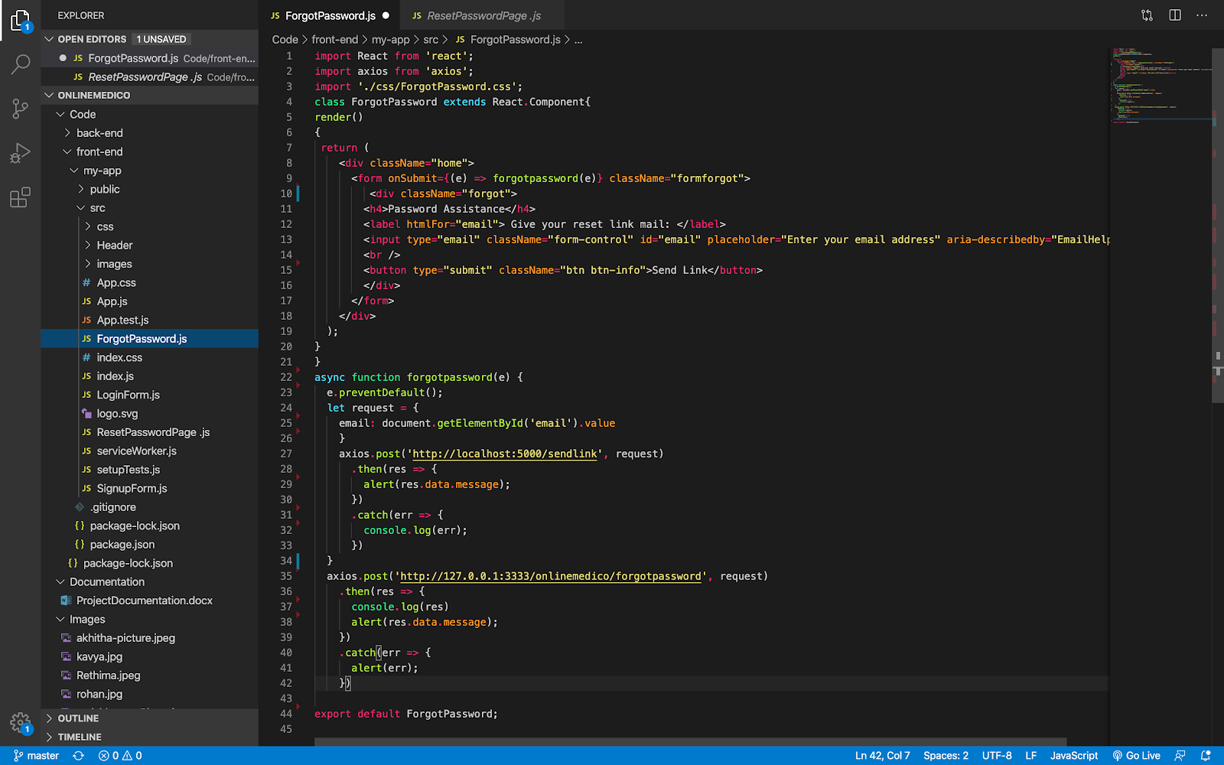

Backend:
Migration files:
These files are used to create the table schemas in the database. Each file refers to one table in the database.
1. Customer table:
In these the attributes are first name, contact number, email and password.
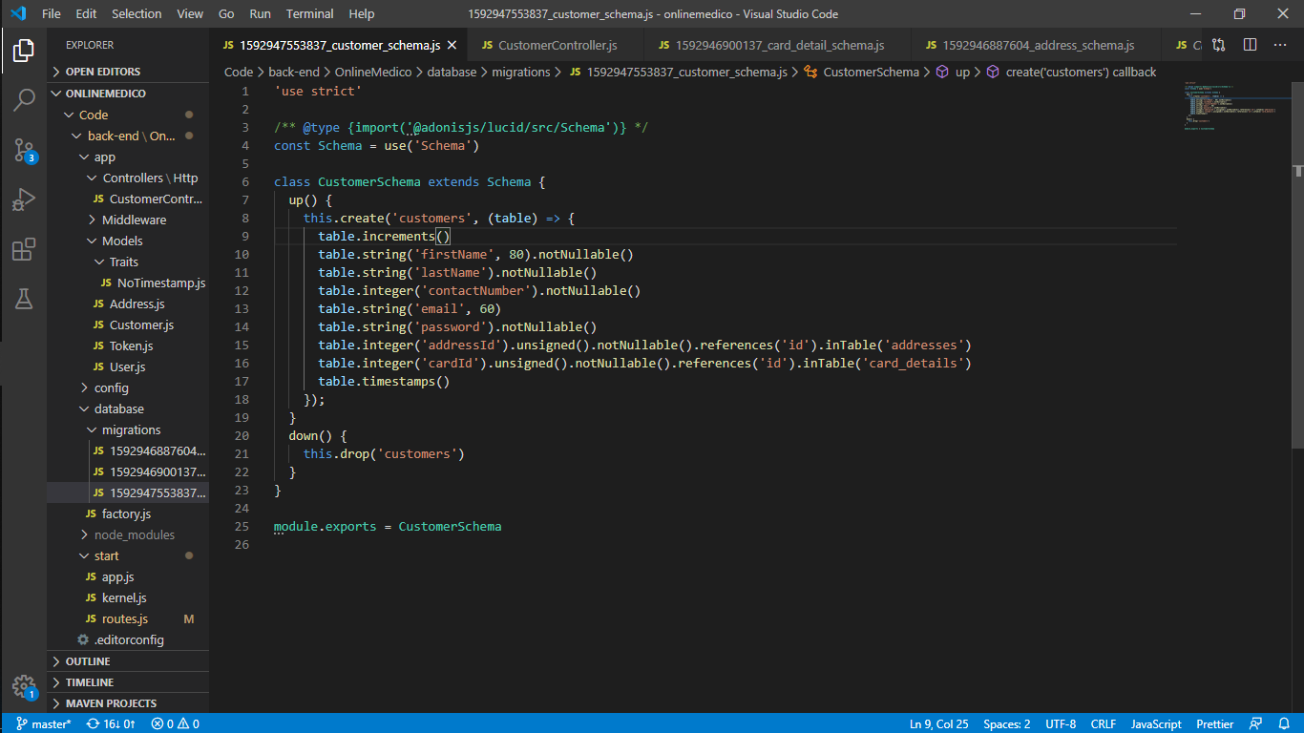

2. Card details table:
In these the data provided by users for payments are stored.
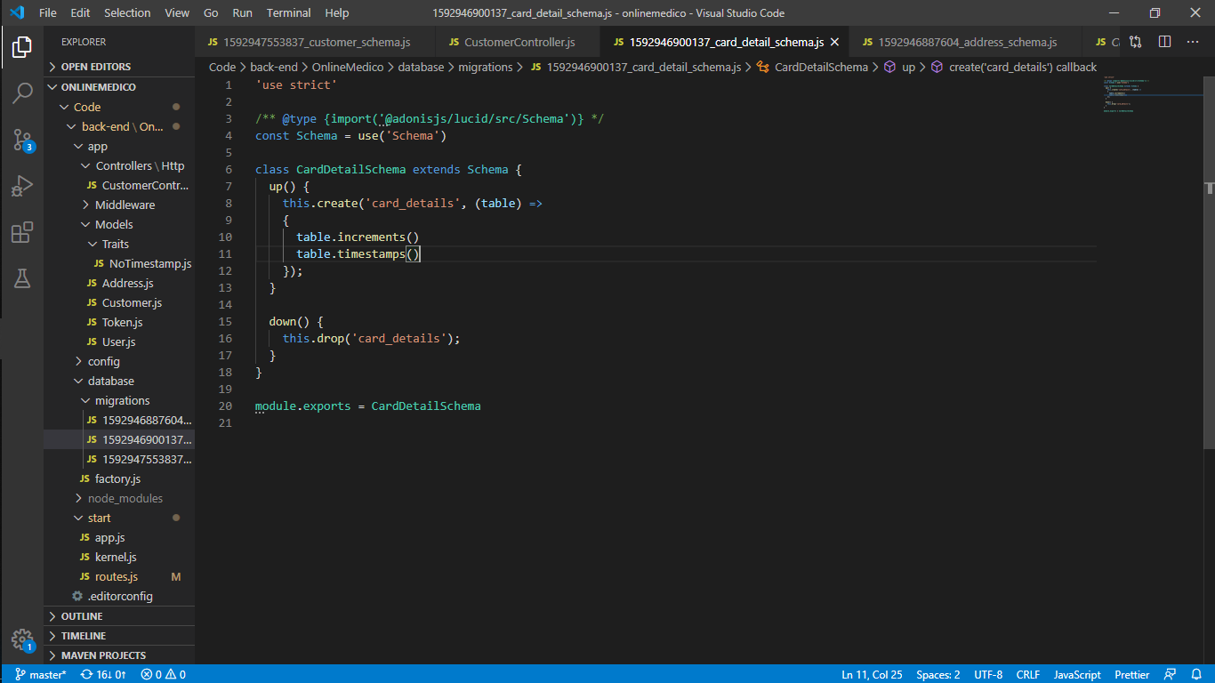

3. Address table:
As each and every user has an address field, despite the type of users we are storing the address in separate table to reduce the redundancy. In these the details of the user's address is stored. In this table attributes are street, city, state, country, zip.
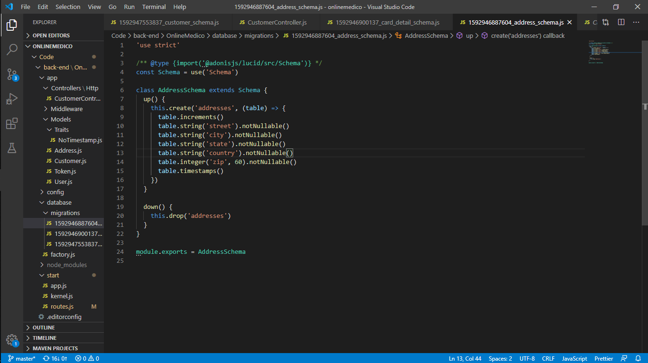

Signup Functionality:
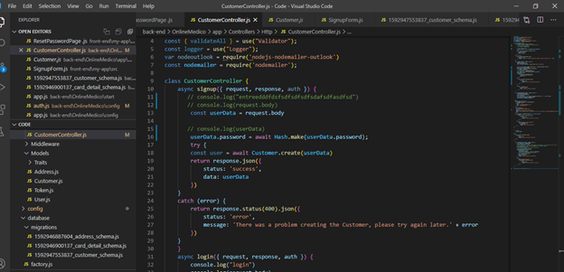
This function will execute when the signup button is clicked and here we are taking the object which contains sign up information and store in the database using the Customer model. Here we are using a hash function to hash the password to store in the database.

Login Functionality:

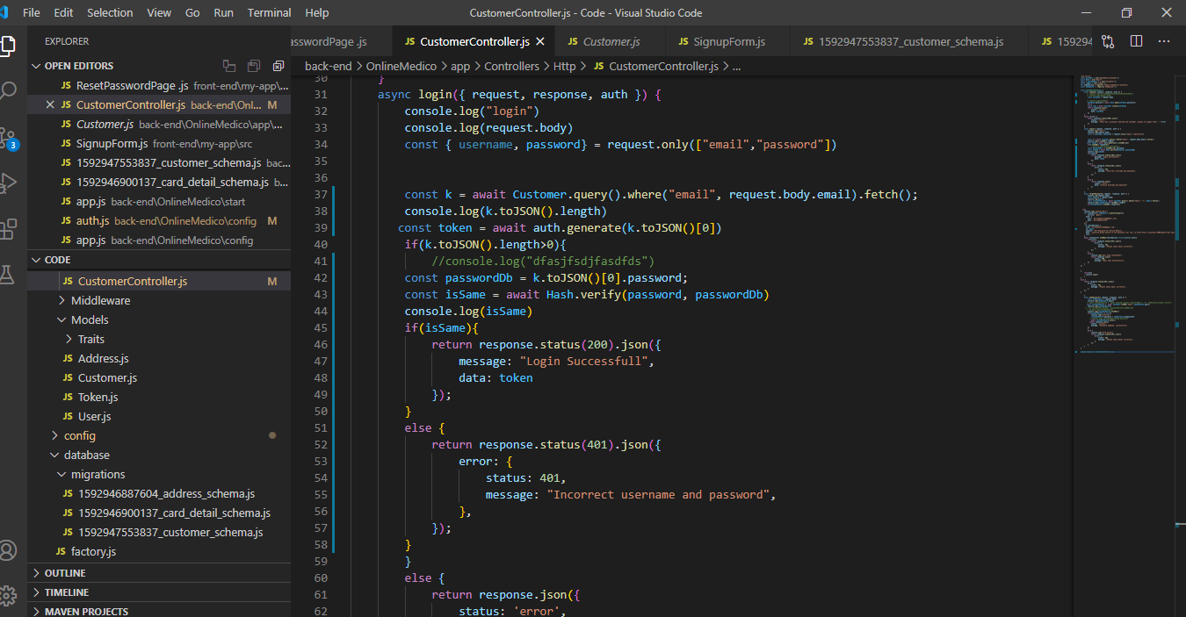
This function will execute when we click on the login button . In this method we are going to take a json object which contains login information and check whether this email and password exists in the database or not. Here we are using a hash verify method to compare passwords.

Forgot Password Functionality:
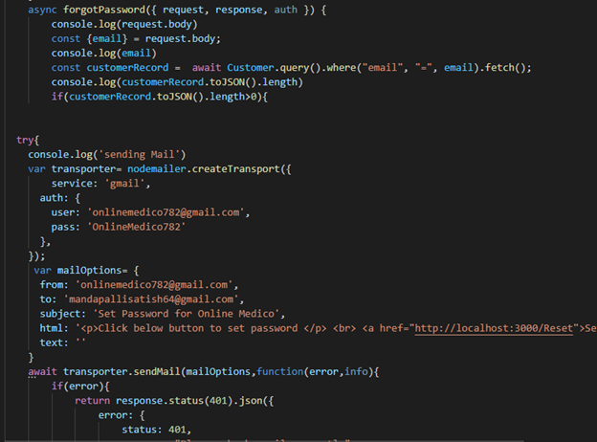

This function gets executed whenever the user clicks on the forgot password button. In this function, we are fetching the customer record through the email which the user gets registered. The mail is sent along with the link by using nodemailer package to reset the password to the registered mail which redirects to the reset password page where the user enters the email along with the new password which will be updated to the database using the new password function.

New Password Functionality:
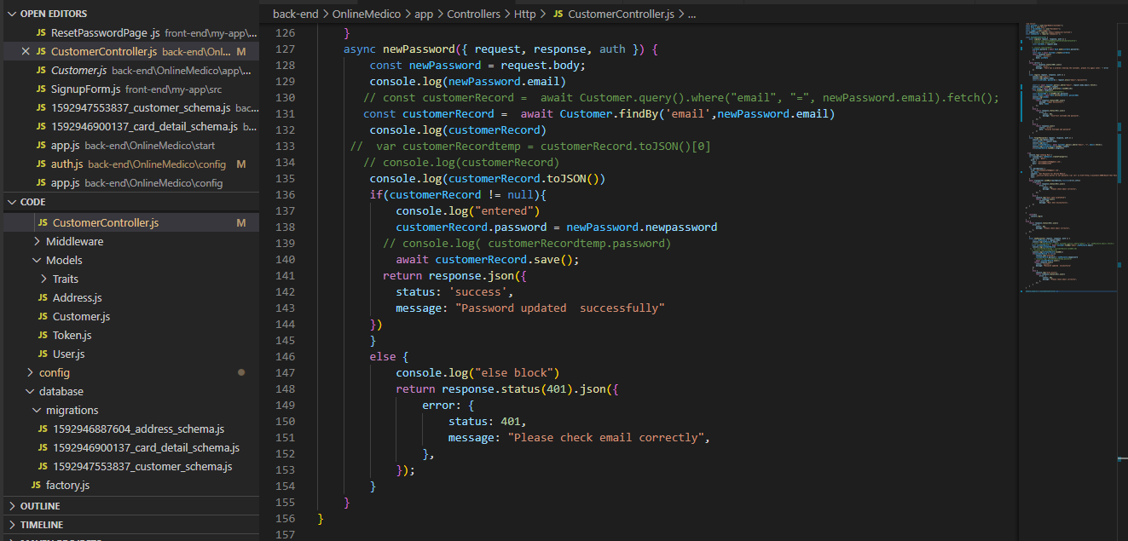
In this method we are updating the password of the user based on email which the user was entered. This method will accept json which contains information about user mail, new password. Upon on successful updation the success object is returned.

Chapter 6: End User Manual
About OnlineMedico:
OnlineMedico, will help people find their medication and buy them easily. This website makes the user find the available store to buy their medications. Once they are found, users can order medicines for delivery through our application.
Sign up page:
To make use of our application any user must have an account in our application OnlineMedico. Using this signup page, they can create an account. Once the user enters this page, they need to enter details like full name, contact number, mail Id and password. If the user already has an account, they can click on the login link provided. The page appears as below.
Login Page:
Any user has to login to use the features of our application OnlineMedico. They just need to enter their mail Id and password which they used during registration. If the user is new to our application, a link to registration is also provided on this page. In case, if the user forgot password, they can click on the relevant link to go through the password retrieval functionality.
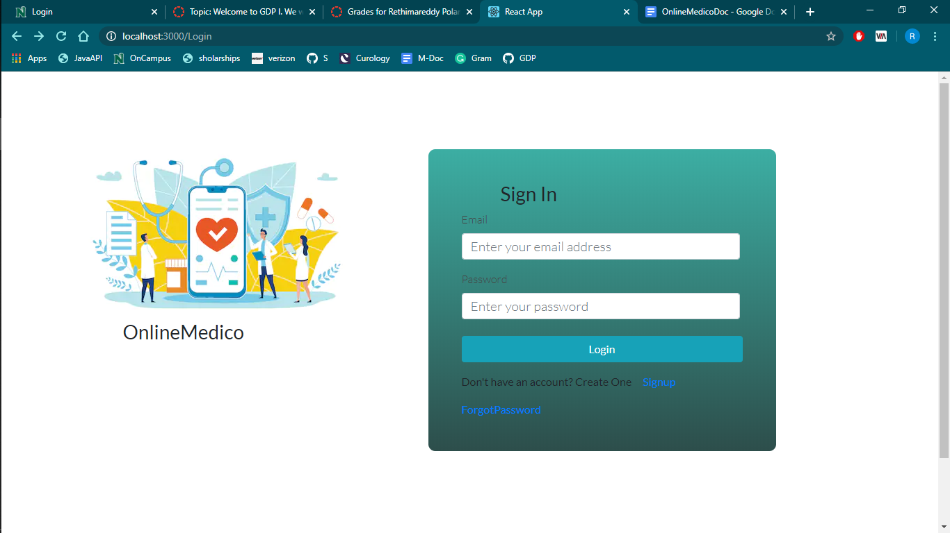
Forgot Password Page:
If User forgot a password, they can click on the forgot password link which will be redirected to the forgot password page as shown below.User must enter the email id used in registration and when send link button is clicked ,a reset password link will be sent to the registered email address.When reset password link in email is clicked, it will redirected to reset password page.

Reset Password Page:
When the user clicks on the link which is provided in mail then the user will be redirected to reset password page. Here the user is going to enter email and new password and click on the submit button.By this user can set a new password in case if the user forgets password.
